Web Service Interaction
In Microservice architecture, the services interact through REST APIs. In order to realize this implementation.
A spring boot application has been created. In which the src folder is deleted.
A module is created with the name UserService
Another module is created with the name ProductService

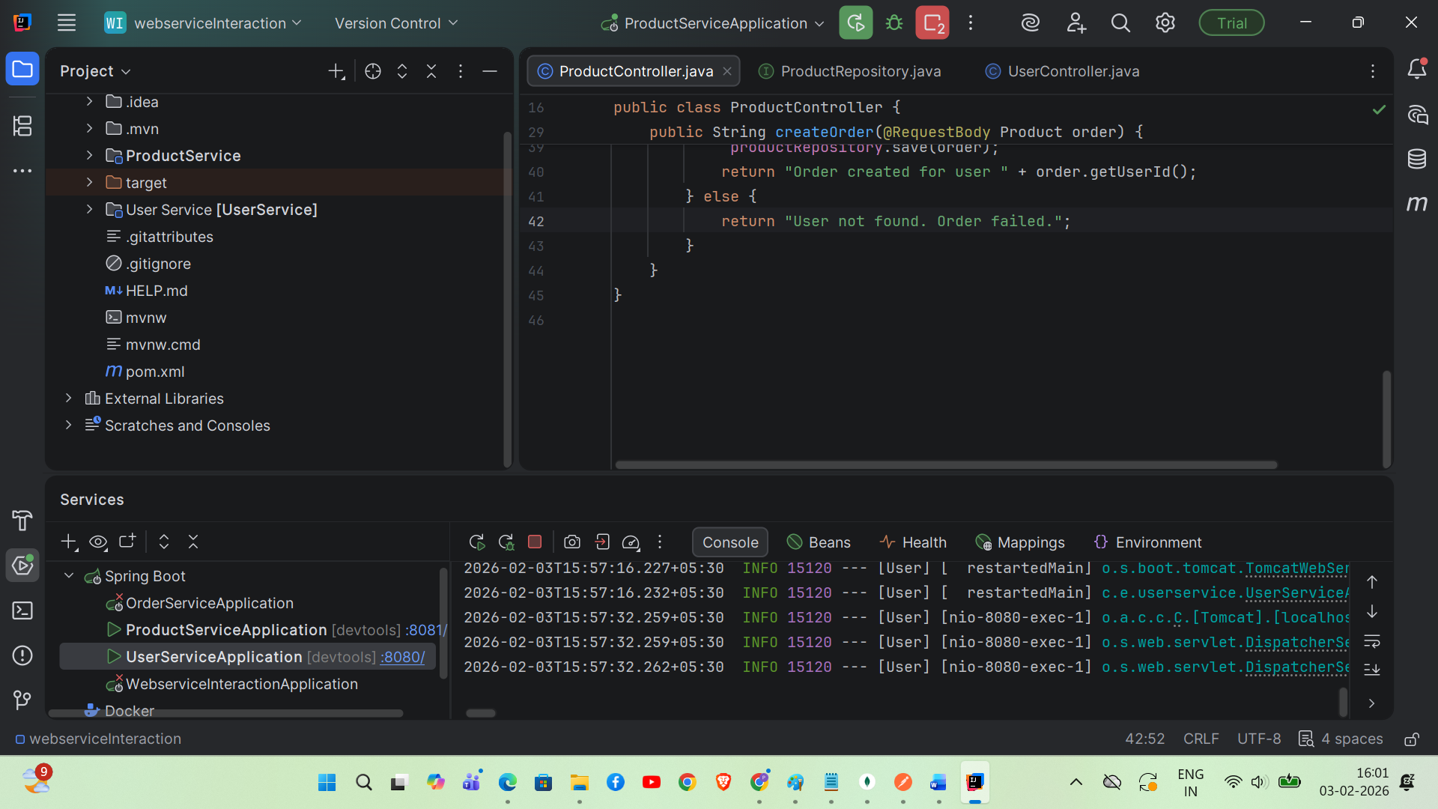

Folder structure for each service is as follows, but in same spring boot application:
However, each is service which can run in different ports, deployable individually
Each service has pom.xml (child) in which the dependencies are saved
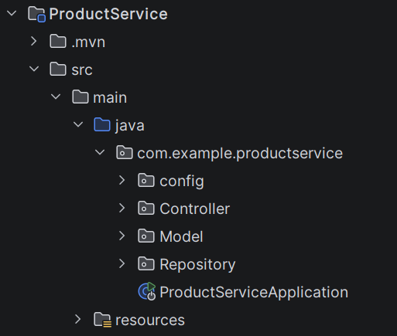 | 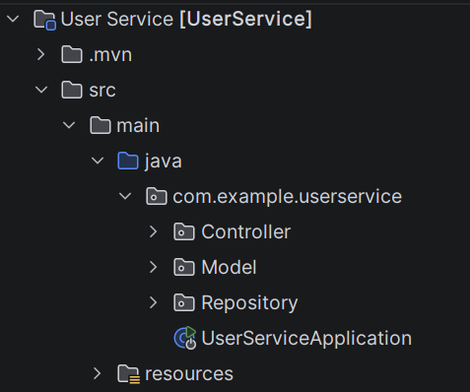

UserService

Resources/application.properties - specifies at which port the service runs

spring.application.name=User
server.port=8080
spring.data.mongodb=mongodb://localhost:27017/E-CommDB
UserController.java handles the HTTP Requests

package com.example.userservice.Controller;
import com.example.userservice.Model.User;
import com.example.userservice.Repository.UserRepository;
import org.springframework.beans.factory.annotation.Autowired;
import org.springframework.web.bind.annotation.*;
import java.util.List;
@RestController
@RequestMapping("/api")
public class UserController {
@Autowired
private UserRepository userRepository;
public UserController(UserRepository userRepository) {
this.userRepository = userRepository;
}
// READ ALL
@GetMapping("/users")
public List<User> getAllUsers() {
return userRepository.findAll();
}
@PostMapping
public User createUser(@RequestBody User user) {
return userRepository.save(user);
}
@GetMapping("/{userId}")
public String getUserByUserId(@PathVariable String userId) {
User user = userRepository.findByUserId(userId);
if (user != null) {
return user.getUserId() ;
} else {
return null;
}
}
@DeleteMapping("/{id}")
public String deleteUser(@PathVariable String id) {
userRepository.deleteById(id);
return "User deleted successfully";
}
@PutMapping("/{id}")
public User updateUser(@PathVariable String id,
@RequestBody User updatedUser) {
return userRepository.findById(id).map(user -> {
user.setName(updatedUser.getName());
user.setEmail(updatedUser.getEmail());
return userRepository.save(user);
}).orElse(null);
}
}
UserRepository.java

package com.example.userservice.Repository;
import com.example.userservice.Model.User;
import org.springframework.data.mongodb.repository.MongoRepository;
public interface UserRepository extends MongoRepository<User, String> {
User findByUserId(String userId);
}
User.java
package com.example.userservice.Model;
import lombok.AllArgsConstructor;
import lombok.Data;
import lombok.NoArgsConstructor;
import org.springframework.data.annotation.Id;
import org.springframework.data.mongodb.core.mapping.Document;
@Data
@NoArgsConstructor
@AllArgsConstructor
@Document(collection="users")
public class User {
@Id
private String id;
private String name;
private String email;
private String userId;
}

Product Service
Reources/application.properties
spring.application.name=ProductService
server.port=8081
spring.data.mongodb=mongodb://localhost:27017/E-CommDB
user.service.url=http://localhost:8080

ProductController.java
package com.example.productservice.Controller;
import com.example.productservice.Model.Product;
import com.example.productservice.Repository.ProductRepository;
import org.springframework.http.ResponseEntity;
import org.springframework.web.bind.annotation.*;
import org.springframework.web.client.RestTemplate;
import java.util.List;
@RestController
@RequestMapping("/orders")
public class ProductController {
final RestTemplate restTemplate;
final ProductRepository productRepository;
public ProductController(RestTemplate restTemplate, ProductRepository productRepository) {
this.restTemplate = restTemplate;
this.productRepository = productRepository;
}
@GetMapping("/disp")
public List<Product> getAllProducts() {
return productRepository.findAll();
}
@PostMapping("/create")
public ResponseEntity<String> createOrder(@RequestBody Product order) {
String userServiceUrl =
"http://localhost:8082/users/searchuser/" + order.getUserId();
try {
restTemplate.getForEntity(userServiceUrl, Void.class);
repo.save(order);
return ResponseEntity.ok("Order created for user " + order.getUserId());
} catch (org.springframework.web.client.HttpClientErrorException.NotFound e) {
return ResponseEntity.badRequest().body("User not found. Order failed.");
}
}
}
ProductRepository.java

package com.example.productservice.Repository;
import com.example.productservice.Model.Product;
import org.springframework.data.mongodb.repository.MongoRepository;
public interface ProductRepository extends MongoRepository<Product, String> {
}

config/AppConfig.java
package com.example.productservice.config;
import org.springframework.context.annotation.Bean;
import org.springframework.context.annotation.Configuration;
import org.springframework.web.client.RestTemplate;
@Configuration
public class AppConfig {
@Bean
public RestTemplate restTemplate() {
return new RestTemplate();
}
}
Product.java
package com.example.productservice.Model;
import lombok.AllArgsConstructor;
import lombok.Data;
import lombok.NoArgsConstructor;
import org.springframework.data.annotation.Id;
import org.springframework.data.mongodb.core.mapping.Document;
@Data
@NoArgsConstructor
@AllArgsConstructor
@Document(collection="order")
public class Product {
@Id
private String orderId;
private String userId;
private String productName;
}

Conceptual Understanding:

Simple Microservice Interaction Example
Order Service needs user details, So Order Service calls User Service.

Services Involved
User Service
- Stores user information
- Exposes REST API
Order Service
- Creates orders
- Calls User Service to verify user

Test the User Service for the existence of user
User Service Endpoint
GET http://localhost:8080/api/U101
Sample Response
No Error OK 200 Means user U101 exists
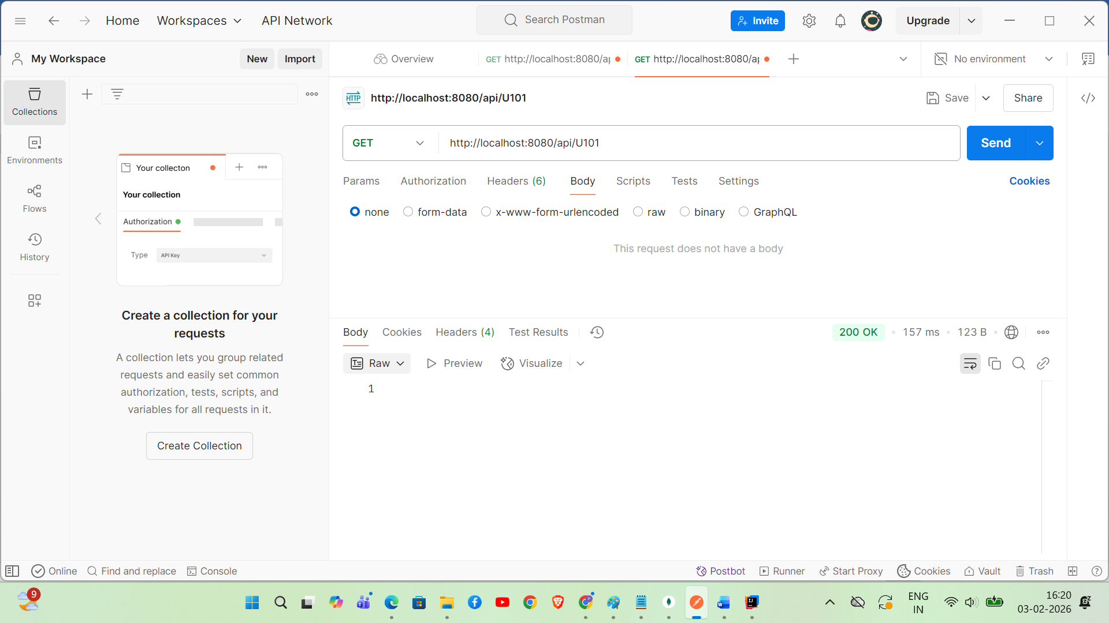

Responsibility of Product Service
- Accept order request
- Call User Service
- Create order only if user exists

How Interaction Happens (Flow)
Client
|
POST /orders
|
Order Service
|
GET /users/{id}
|
User Service
|
User exists → OK

